Layer 4 — Enterprise System Complexity
Multi-Dimensional Complexity
- Enterprise ERP systems must support organizations operating across multiple legal entities, locations, and accounting frameworks.
- In NetSuite, this complexity is handled through several structural dimensions that influence how transactions behave and how financial data is recorded.
- The three most important dimensions affecting Item behaviour are:
  - Multi-Subsidiary Architecture
  - Multi-Location Inventory
  - Multi-Book Accounting
- Each dimension introduces additional financial and operational considerations that must be carefully configured during system design.
- Because Items participate in nearly every transaction, their configuration must align correctly with these enterprise structures.

Multi-Subsidiary Architecture
Definition
- In NetSuite OneWorld, a Subsidiary represents a legally separate business entity within an organization.
- Each subsidiary maintains its own:
  - Financial records
  - Tax obligations
  - Currency environment
  - Regulatory reporting requirements
- Items must be explicitly enabled for each subsidiary in which they are used.

Key Characteristics
- Multi-subsidiary environments introduce several architectural rules:
  - Items must be enabled individually per subsidiary
  - Financial account mappings may differ between subsidiaries
  - Revenue and expense accounts may vary by entity
  - Currency conversions may apply across subsidiaries
  - Intercompany transactions may occur between subsidiaries
- This structure allows organizations to maintain separate financial reporting for each legal entity while operating within a unified ERP platform.

Intercompany Impact
- When transactions occur between subsidiaries, NetSuite generates intercompany entries to maintain accounting balance.
- Example:
  - Subsidiary A sells inventory to Subsidiary B
  - Financial effect:
    - Subsidiary A
      - Dr Intercompany Receivable
      - Cr Revenue
    - Subsidiary B
      - Dr Inventory
      - Cr Intercompany Payable
- These entries ensure that balances reconcile during financial consolidation.

Multi-Location Inventory
Definition
- Multi-Location Inventory allows organizations to track inventory across multiple warehouses, distribution centers, or retail locations.
- Each inventory transaction must reference a specific location.
- Locations determine where inventory is stored, fulfilled, and valued.
Key Characteristics
- Multi-location environments enable:
  - Inventory quantity tracking by warehouse
  - Location-specific inventory valuation
  - Transfer of inventory between locations
  - Location-based fulfilment processes
- Each location is typically associated with a subsidiary in OneWorld environments.

Inventory Transfer Impact
- Moving inventory between locations creates inventory movement records and may affect valuation reporting.
- Example:
  - Warehouse A → Warehouse B
  - Accounting impact:
    - Dr Inventory – Location B
    - Cr Inventory – Location A
- Although total inventory value remains unchanged, location-level inventory balances are updated.

Costing Considerations
- Multi-location environments also influence costing behaviour.
- Examples include:
  - Cost layers maintained per location
  - Location-based inventory valuation reporting
  - Backdated transfers affecting historical cost layers
- Because of this, organizations must maintain strict operational discipline when managing inventory across locations.

Multi-Book Accounting
Definition
- Multi-Book Accounting allows organizations to maintain multiple accounting ledgers derived from a single operational transaction stream.
- Each accounting book may follow different accounting standards.
- Examples include:
  - Corporate reporting under IFRS
  - Local statutory reporting under regional GAAP
  - Tax reporting under jurisdiction-specific rules

Key Characteristics
- Multi-Book environments support:
  - Different charts of accounts per accounting book
  - Separate revenue recognition rules
  - Book-specific depreciation or amortization
  - Independent financial reporting per accounting standard
- A single operational transaction can therefore generate multiple accounting postings across different books.

Example Scenario
- An international organization may maintain two accounting books.
- Primary Book → Corporate Financial Reporting
- Secondary Book → Local Statutory Reporting
- Each accounting book may apply different revenue or cost recognition rules.

Enterprise Configuration Risks
- Incorrect configuration across enterprise dimensions can create significant financial reporting issues.
- Common risks include:
  - Items not enabled for required subsidiaries
  - Incorrect inventory location assignments
  - Inconsistent account mappings across accounting books
  - Improper intercompany transaction configuration
- These issues can lead to reconciliation failures during financial consolidation.

Governance Considerations
- Organizations operating in multi-dimensional environments should enforce strict governance controls.
- Recommended practices include:
  - Finance approval of subsidiary-level account mappings
  - Inventory transfer controls between locations
  - Periodic review of multi-book account mappings
  - Regular reconciliation of intercompany balances
- Strong governance ensures consistent financial reporting across complex enterprise structures.
Architectural Insight
- Multi-dimensional configuration is what enables NetSuite to function as a global ERP platform.
- By combining subsidiaries, locations, and accounting books, NetSuite can represent complex corporate structures while maintaining a single operational transaction system.
- However, this flexibility introduces additional configuration complexity, requiring careful system design and ongoing governance oversight.
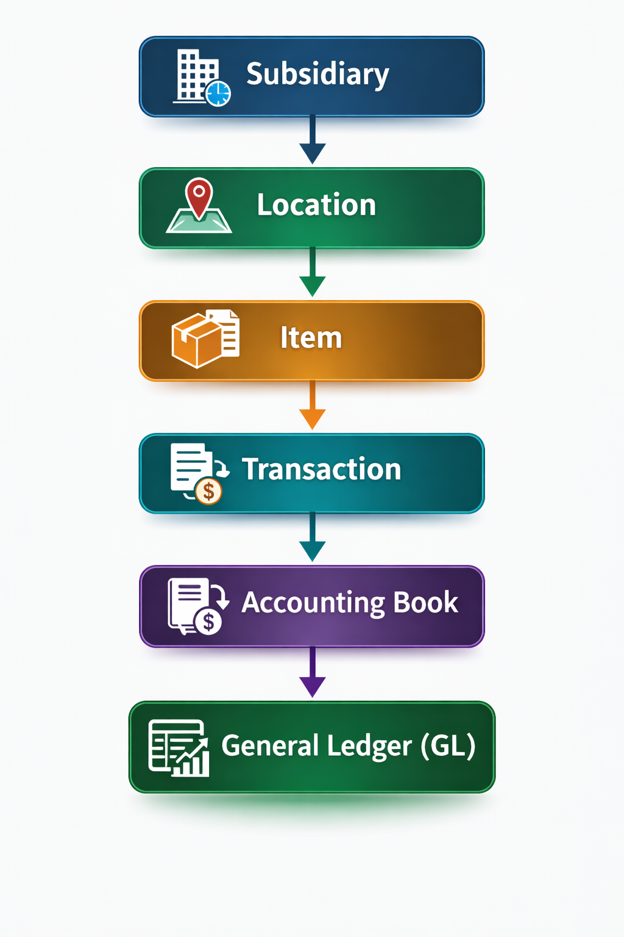

Feature Enablement Impact
- Item behaviour changes when enabling:
  - Advanced Revenue Management
  - Advanced Inventory
  - Work In Process
  - Landed Cost
  - Multi-Book Accounting
  - Multi-Subsidiary Customers
- Feature activation increases financial complexity.

